XQD and SD Card Reader
Professional-Class XQD"M, SDTM and USB3 Adapter
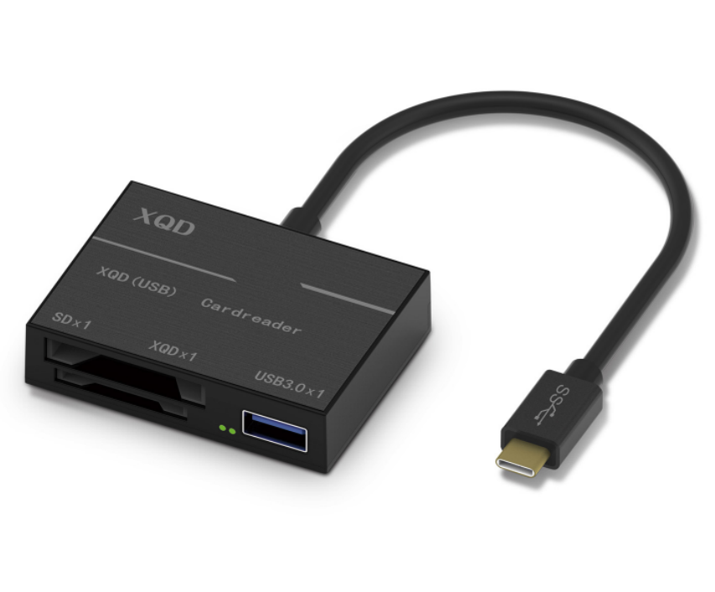

Descrption:

XQDTM is the latest in high-performance, high-capacity memory cards featured in the latest DSLR and mirror-less cameras from NikonTM, SonyTM, Phase OneTM and is sure to be the stable diet of still image and 4K video storage for future imaging devices.

Using the high-speed Type-C interface, not only is a XQDTM reader included but also a SDTMHC slot for UHS-I/II memory cards. Included is a standard USB3.0 port which allows connection to almost any other USB device, such as flash drives, storage etc and can be used simultaneously with the other onboard memory card slots.

Features:
- XQDTM transfer speeds up to 4-Gbits/s, 500Mbps
- Ultra-fast RAW, JPG, 4K or higher file copies from memory cards
- SonyTM, LexarTM and other compatible XQDTM support
- SDTMHC reader, compatible with UHS-I/II SDTM cards
- USB3.0 port for connection to almost all USB devices
- Type-C connectivity - self-powered and Plug n' Play

Specifications
- Material: ASB Housing
- Cable Length: 11.5cm
- Color: black
- Input：type c
- Output：SD card/XQD card/USB
- Speed：1G takes 2 minutes and 30 second normally
- Quality：High and stable
- Certificate: CE FCC ROHS
- Operating Temperature:0℃ to +45℃
- Operating Humidity:10%0 to 85 % RH
- Storage Temperature : -10℃ to +55℃
- Storage Humidity: 5% to 90 % RH

Product Code:
Part number: C-TC-CR-USB3
Barcode: 8400800036568
Size: 45mm x 6mm x 14mm

